

FortnaPlus Control
On-Screen Buttons
Document Revision: 1.2
Date: 21-Sep-2022

Revision | Date | Author | Revision Summary
0.1 | 23-Sep-2013 | B C Conklin | New document
0.2 | 29-Sep-2013 | B C Conklin | Updates
1.1 | 22-Jun-2022 | T R Kremser | Update and General Refresh
1.2 | 21-Sep-2022 | T R Kremser | Add note about the size of the Layerson table.

Table of Contents
1. Section 4
2. Section 4
3. Section 4

Confidential/Proprietary Statement
This document contains trade secrets and information that is considered confidential and proprietary to Fortna, Inc. It may not be duplicated, used, or disclosed outside the original recipient organization, and it may not be duplicated, in whole or in part, for any purpose other than to evaluate this document. Fortna Material Handling reserves the right to modify this document as necessary to reflect any terms and conditions negotiated and included as part of a subsequent contract or purchase order.

Glossary of Terms
AC – Automation Controller
FPC – FortnaPlus Control
UPS – Uninterruptible Power Supply

Introduction
This detailed design document contains the software design details for creating an on-screen button.
This document is intended for use by the Software Development team and the Controls Engineering team.

Project Overview
The goal is to create an on-screen button that is easy for the operator to access. The button will allow interaction with the desired components of the system through configuration alone – no code changes necessary. This is done by attaching the button to an IO input bit.
  - Automation Controller Main Screen
Here is an example of an AC main screen Conveyor diagram:
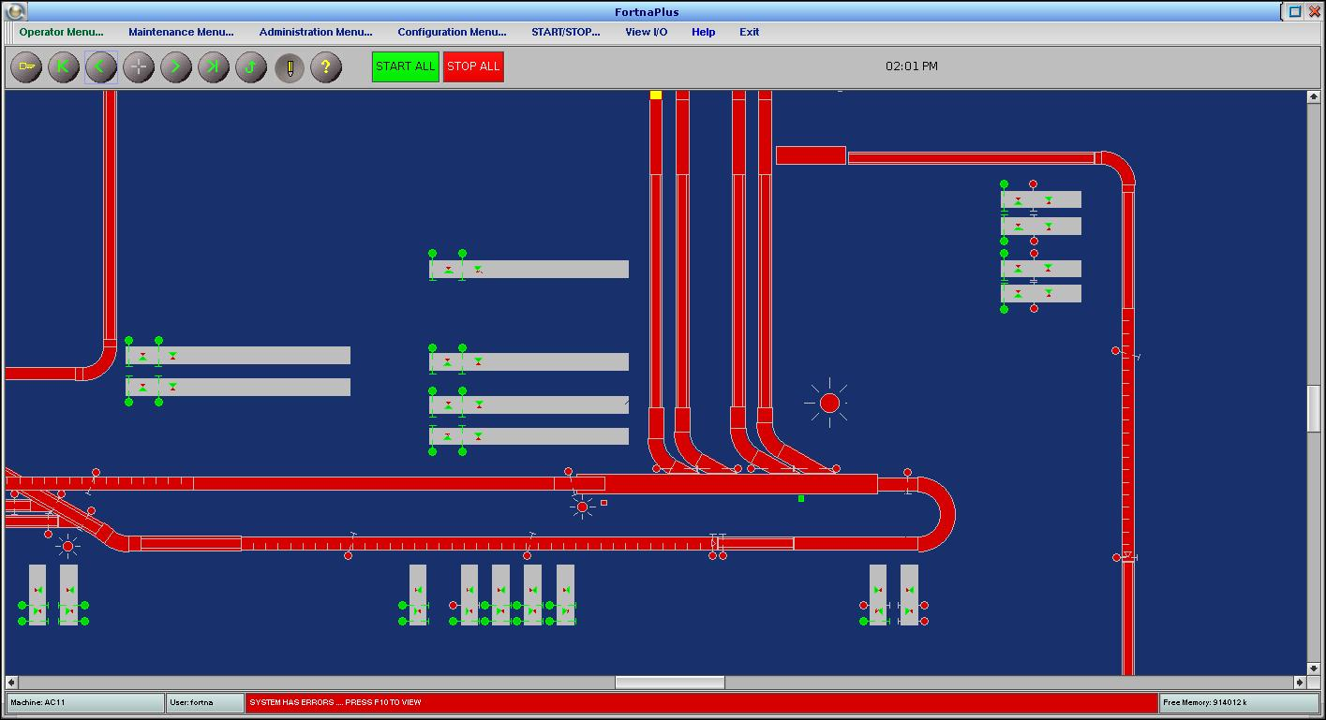
  - High-Level Summary
A button is defined as another Conveyor part, with an associated IO bit. In order to control visibility of the button so it appear only on the appropriate AC, it is placed on its own layer.
We will create an example button used to enable / disable a sorter lane.
    - Issues
The code behind a button uses the IO Force feature to control the attached IO bit. The force will override any use of enable / disable bits. Also, by default, forced IO will override the state of an IO bit owned by another AC. This behavior can be changed using the Integer Flags (flagmenu) FLAG_PROTECTFORCE. By default, it is set to 1 to protect the force setting locally. If set to 0, forces from another AC will be honored.

Automation Controller Configuration
Details on how to configure an on-screen button.
  - The Create Conveyor Part (PartPfgScrn) Screen
Use the PartPfgScrn screen (Configuration Menu | Standard Controls | Create Conveyor Part or Configuration Menu | Wizard Utilities | Create Conveyor Part). We will create a new part that will become our on-screen button. We also use this screen to create a memory bit for the button. This method creates a 16-bit memory word, of which we will use one bit. If you have an existing memory word with unused bits, you can use one of those.
After creating the new part, it is best to restart FPC.
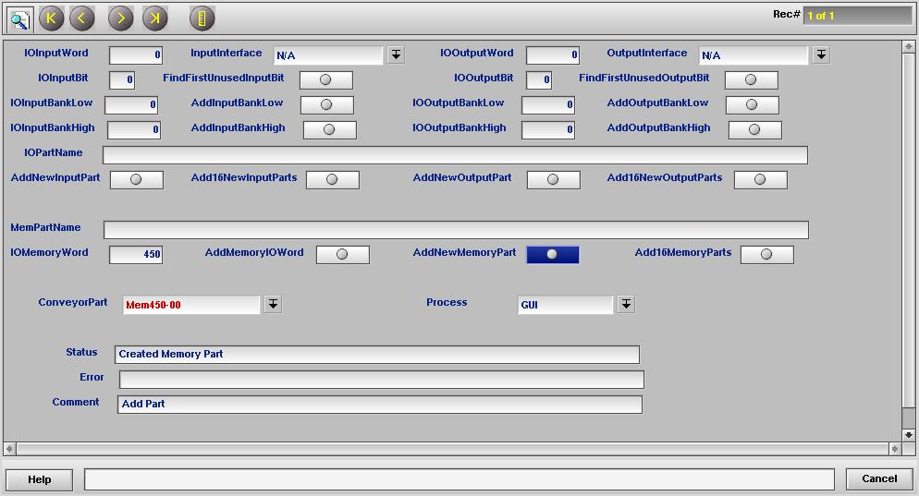
    - Process
Select the GUI process using the drop-down. This defines the process that owns and can control the IO bit associated with the part.
    - IOMemoryWord
Use the View I/O screen to find an unused word, and enter the value in the IOMemoryWord field.
    - AddMemoryIOWord
Click the button next to AddMemoryIOWord to create the memory word set in the previous step.
    - AddNewMemoryPart
Now that we have a new memory word to use, create a new memory part within that word by clicking AddNewMemoryPart. This creates a new part in table Conveyor, just before the END marker. The automatically generated part name appears in the ConveyorPart field.
  - Conveyor Table
Open the Conveyor table and jump to the newly-created part by right-clicking the down arrow next to ConveyorPart. You could also open Conveyor from Configuration Menu | Standard Controls | IO Conveyor, then click the Find End Marker “>>” button to jump to the end marker, then Prev “<” to go back one part, or search for the part by name.
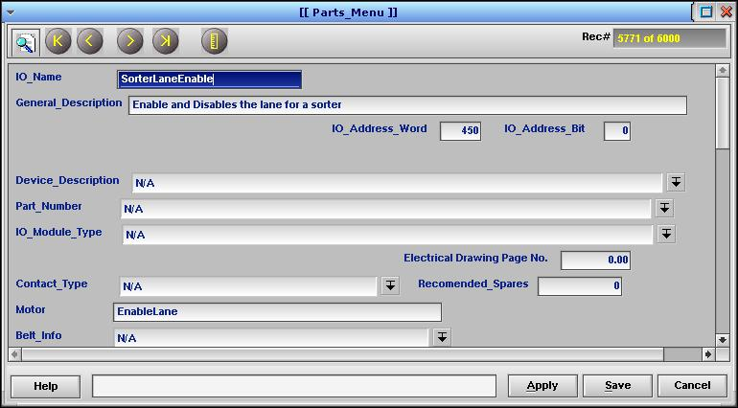
    - IO_Name
Rename the newly-created part to a more descriptive name.
    - General_Description
The General_Description field is the string displayed on the View I/O screen. A process name may also be entered here. See 3.2.13 Gen_Flag, below.
    - IO_Address_Word
This is the IO word, as assigned from the PartPfgScrn.
    - IO_Address_Bit
This is the IO bit, as assigned from the PartPfgScrn.
    - Motor
The text defined in Motor will appear on the button. For this example, set the text to “SorterLaneEnable”.
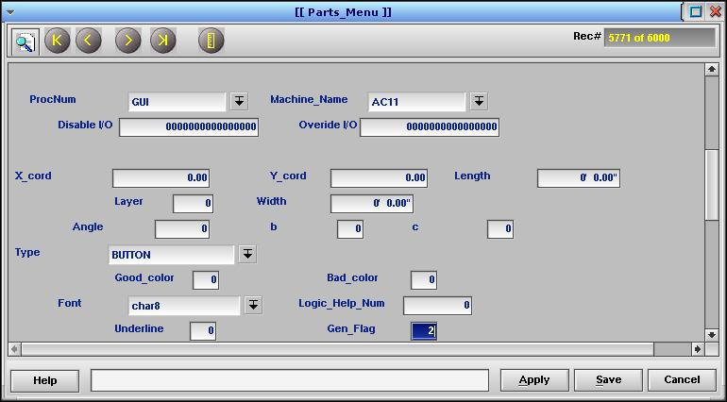
    - ProcNum
ProcNum defines the process that owns this part. It is already set to GUI from the PartPfgScrn. It must be controlled by GUI so that the user can click on it.
    - Machine_Name
Machine_Name defines the AC that owns this part. It has been set to the current AC by the PartPfgScrn.
    - X_cord, Y_cord
These fields control the on-screen position of the button. To easily set the position, make sure the  “Part Edit Mode” button on the main screen toolbar is activated (the pencil turns yellow when active). With the Conveyor table open, click the main screen where you want the button to be. The X_cord and Y_cord values will update to the location you clicked. Note: The button will not be visible yet.
    - Length
Set the width of the button (X direction). The format is feet and inches.
    - Width
Set the height of the button (Y direction). The format is in feet and inches.
    - Layer
The Layer field controls which display layer the button will be drawn on. There are 20 layers defined. Each layer can be made visible individually.
For this example, set Layer to 20. This will be used later to hide the button on ACs that do not need it.
    - Type
Type defines how the part is displayed on the main screen and sets its behavior in the code. Set Type to BUTTON.
    - Gen_Flag
Gen_Flag (in honor of our colleague Gen Gladchun) defines the button action. Set it to 2 – Trigger IO.
The IO bit will be toggled ON and OFF using a Force each time the button is clicked.
A non-zero value here will also cause the program to check the General_Description for a procedure name to run. If the string exactly matches a procedure found in procnames_Procedure_Name, that procedure will be run when the button is clicked. A good example for testing is “Show Clock” which makes the clock appear on the main screen button bar.
    - Gen_Security
Gen_Security, also a homage to our buddy Gen, is used to assign security to the button (but only for the IO toggle feature). Double-click the field to open the Role Editor. The user’s roles must overlap with the roles set here for the user to gain access. A value of zero means anyone can click the button.
  - ButtonFontZoom Table
Use the ButtonFontZoom table (Configuration Menu | Zoom Fonts Utilities | Set Button Fonts) to control when the button is visible. Select all the zoom levels where buttons should be visible using the LevelEnabled column. There are nine zoom levels, with row 0 the most zoomed-out level (The Zoom out max button), and row 8 representing the most zoomed-in level (The Zoom in max button). The Font column can be used to set the font for the text on the button. Note that some fonts cannot be rendered at some zoom levels. The button will be visible on screen after this is set, though you may have to change zoom level to get the changes to take effect. You may need to adjust your button size to make it visible when zoomed out.
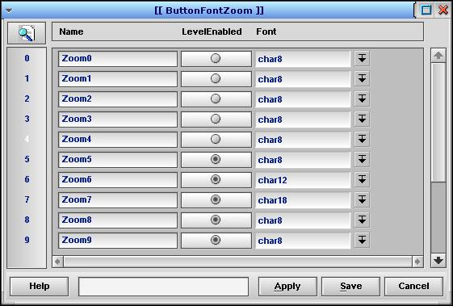
    - Name
Set a unique name for each row (optional). It is best to name them for their row number, as shown.
    - LevelEnabled
Check the box to enable display of buttons at the given zoom level. If the text for the button does not fit on the button, it will not be rendered. Setting this will make the button visible. If it does not appear, change zoom level to make your change take effect.
    - Font
Choose the font to render the button text at this zoom level. Some trial and error will be necessary.
  - Layerson Table
Use the Layerson, or LAYERS table (Configuration Menu | Administrator Utilities | Edit Layer Sets) to control the visibility of each layer. To hide the button on ACs that do not require it, set the layer field for the layer number (20, in our example) to N for the Layer_Set in question.
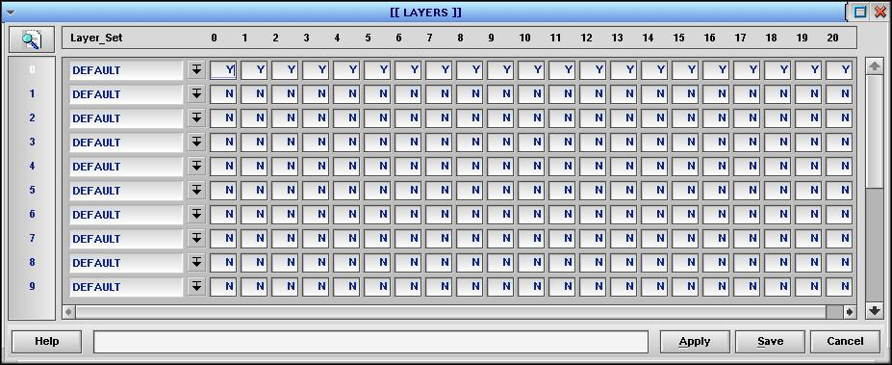
    - Layer_Set
You can define multiple layer sets.
    - Columns 0 – 20
There is a column for each of the 20 possible layers. Set the field for the Layer_Set in question to Y to display the layer or N to hide it.
For our example, set column 20 to Y on the AC where the button is to be used, and to N on all the other ACs.
NOTE: Make sure the Layerson table has at least 21 rows! There are actually 21 layers (0 thru 20). Older FPC versions have the table set to 20 rows. If you don’t have enough rows, the symptom will be that the button parts defined for layer 20 will get reset to layer 0 after a restart.
  - Integer Flags Table
An alternative to hiding the button layer on other ACs is to disable the ability of forced IO to override the state of the IO on another AC. Use The flagmenu table (Configuration Menu | Flag Utilities | Integer Flags), row 75 – FLAG_PROTECTFORCE to control this. It is set to 1 by default, which makes an AC use its own local force value and not accept a force from another AC, no matter which AC owns the IO. To allow forces to propagate from another AC, set the flag to 0.
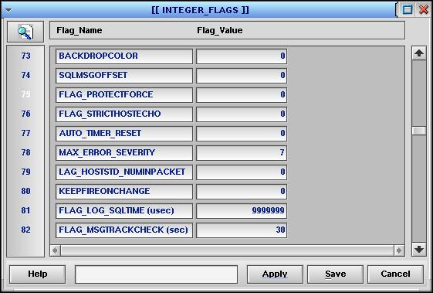
NOTE: There is a bug that prevents this from working! You can set it to 0, but at the next restart, the initialization routines will set it back to 1, since 0 is seen as an “unset” value. Unfortunately, only the value of 0 will allow force propagation. This should be fixed so, perhaps, a value of 2 allows force propagation.

